# Architecture II Tutorial 3 Report

## John Sinclair - 16325734

### Q1

### Q2

### Q3/4

Code:

Imports and global variables:

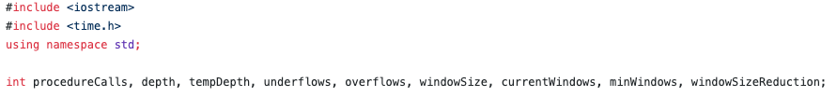

compute_pascal function:

main function:

Console Output:

### Q4

I used the clock function of clock_t imported from time.h. the clock function can result in inaccuracies as the function itself is arbitrary so you must use the macro CLOCKS_PER_SEC to convert the value to real time.

I found the length of time to compute the release version of compute_pascal was about 0.18 seconds.